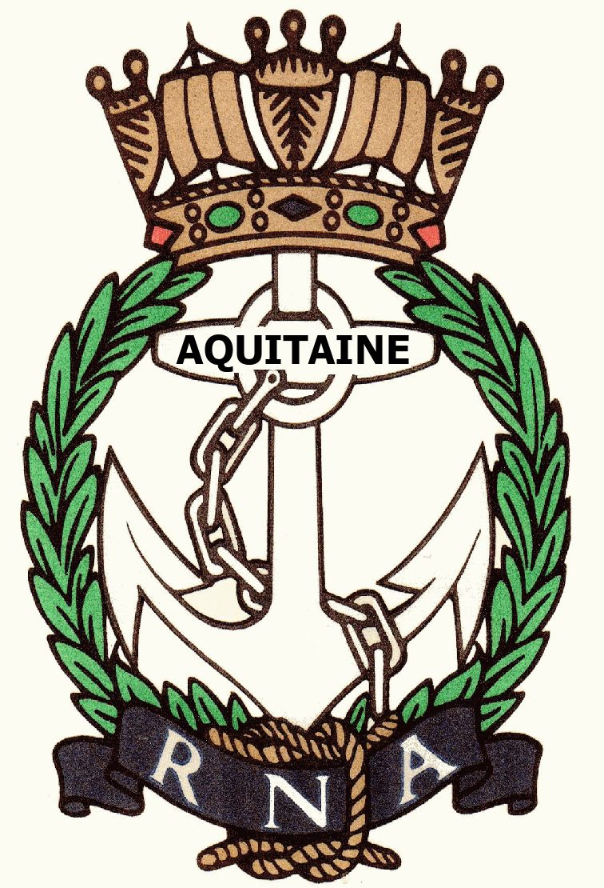
AQUITAINE BRANCH – ROYAL NAVAL ASSOCIATION
Chairman Shipmate Ken Napier MBE
Chazarem, 47290 Beaugas
Email napier.chazarem@wanadoo.fr www.rna-aquitaine.com Tel 05 53 01 70

MINUTES OF ANNUAL GENERAL MEETING 2019 HELD AT LE SEMILLON, MONBAZILLAC ON WEDNESDAY 13TH MARCH 2019

PRESENT: Ken Ayling, Chris Barnacle, Jeannette Kastelein, Ken Napier, Sue Napier, Dave Pegg, Ray Pemble, Di Pemble, Don Pike, Dave Rolfe, Liz Rolfe, Anne Scanlan

APOLOGIES: Richard Amott, Joan Amott, Ken Checkett, Chris Haskell, Antoinette Henry, Marion Hirst, Brian Johnson, Jill Johnson, Andrew Main, Gareth Mulloy, David Rollston-Smith, Patrick Sturges, Didier Villiers, Martine Villiers

APPROVAL OF MINUTES FROM LAST AGM: The Minutes were approved as a record of the last Annual General Meeting. Proposed Dave Pegg, Seconded Ken Ayling.

ELECTION OF COMMITTEE: Dave Pegg retired as Treasurer after a number of years in post. Don Pike volunteered to take on the job and was unanimously elected!. That left the post, formerly filled by Don, of Assistant Secretary vacant. No immediate volunteer was forthcoming.
The remaining Committee Members were happy to stay on in post.
Ken proposed a vote of thanks to Dave for his years as Treasurer and the Auditors commended him on his book keeping. There were no volunteers to be raffle organiser either.

CHAIRMAN’S REPORT: Ken reported that as of 31st December 2019 we had 39 full members, 31 associate
Members, 1 life member and 1 honorary member, which kept our ratio of full members to
associate members at 4:3. He also stated we have lost a further 4 associate members this year
due to people moving away or ill-health. He stated we had 11 lunches in 2018 – July’s was
cancelled due to lack of support (and excess heat!). Average lunch attendance was 24 and average cost 22€. He pointed out that with the rising cost of living keeping the cost below
20€ was difficult. He also told everyone that we are always invited to the AGMs and lunches
of the various AMMACs with whom we are associated. He went on to thank the individuals who help to keep the RNA running – Dave Pegg as outgoing Treasurer for taking the lunch money,
Brian Johnson for his excellent menus and maintenance of our website, Ken Ayling for his support as Vice-President, rum bosun, and procurer of RNA stamps, Neil Wilde for parading the Standard and Liz Rolfe for her welfare role with cards etc.
Ken pointed out that the RNA’s central monthly newsletter is available on line.
He explained that we have less available income from subs and raffle money this year due to the
drop in numbers. This leaves less for welfare and charitable donations.
The RNA is still twinned with RFA WAVE RULER but despite being relatively new she is ‘resting’ in Birkenhead. Our officially affiliated serving man is Darren Houston who has now
left HMS QUEEN ELIZABETH and has been promoted Captain with responsibility for destroyers and frigates based in Portsmouth. Contact with the FREMM AQUITAINE has come to an end due to lack of response on their part..
Formal events – the Standard was paraded in Bergerac on 1st May and 11th November and
wreaths were laid..
It was decided at the last AGM that the library would be dismantled. The books have been
offered to members over the year and it no longer exists.
Ken then thanked those who had attended the AGM for their support.

TREASURER’S REPORT: The Treasurer told us that our annual income totalled 2587€ and expenditure
Totalled 3037€ giving us an overall loss of 450€ (500€ in 2018). He recommended that

charitable donations should only total 1200€ this year to offset the loss. Sue pointed out that £7 from each sub has to be sent to RNA HQ and it was agreed that subs will be paid in sterling to HQ either by Ken or Don and repayment in euros at the recognised exchange rate of the day.
The report was accepted by the members present. Proposed Liz Rolfe seconded Ken Ayling.
Auditors for 2019 Dave Rolfe and Sue Napier

ALLOCATION OF FUNDS: It was agreed that the usual four charities would continue to receive donations –
RNBT, ARNO, WRNSBT and SSAFA. With the Treasurer’s recommendation of 1200€ it was
proposed to give 300€ to each.
Proposed Ken Ayling, seconded Ray Pemble

MEMBERSHIP: The question was ‘should we actively recruit?’. It was decided Ken Ayling would put an ad
into the Group 47 online magazine, to include the RNA website address.

SOCIAL PROGRAMME: Trafalgar Lunch will be on Wednesday 16th October. The Naval Attaché is to be
asked to come as our speaker. It was pointed out that the usual venue of the Ancienne Gare
has closed so another venue needs to be found.
This August is the 20th anniversary of the first lunch of our RNA and February 2020 is the 20th
anniversary of our commissioning. It was decided that August is not a good month to celebrate
as it is high summer with lots of people either away or having visitors, similarly February is
prone to bad weather and dark evenings. The decision was taken to hold it in September 2019
and to celebrate the first lunch held.
Proposed Chris Barnacle, seconded Liz Rolfe
Lia and Dave Rolfe offered to host the June lunch on the 12th June as in the past 2 years.

ANY OTHER BUSINESS: There was no other business and the meeting was closed at 11.57.
Dave Rolfe then proposed a vote of thanks to Ken and Sue for their work over the year. It
was unanimously seconded.

COMMITTEE: Chairman – Ken Napier
Vice Chairman – Ken Ayling
Treasurer – Don Pike
Asst Treasurer – Ray Pemble
Secretary - Sue Napier
Asst Secretary - Vacant

Ex Officio – Welfare – Liz Rolfe
Web Master – Brian Johnson
Standard Bearer - Neil Wilde

